Data Analyst Intern Assessment
Urban Threads — Order & Returns Analytics

1.Executive Summary:

Current Situation:
- Our return rate has spiked from 12% to 19%, resulting in a financial drain of approximately ₹18–22 lakhs per month in reverse logistics and restocking
Primary Objective:
- To implement strategic interventions to bring the return rate below 15% within two quarters.
Key Findings:
- Data shows that Size Inconsistency (45%) and the Instagram Shop channel (74% return rate) are the most significant drivers of these losses.

2. Section - 4: Visualizations & Data Insights

Chart 1: Sales Spikes Lead to a 2-Week Lag in Return Rates

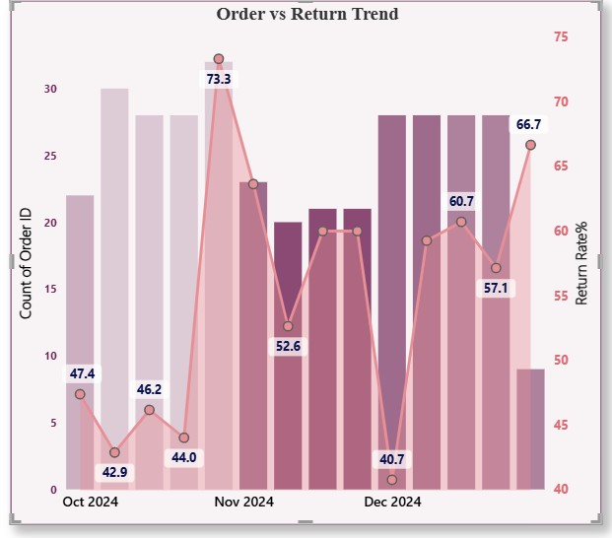

October Peak: Sales reached a peak of 32 orders at the end of October.
Lag Effect: Following this spike, the return rate surged to 73.3% in early November, confirming a clear 14day cycle.
Insight: Operations should prepare for high return volumes exactly two weeks after any major sale peak

Chart 2: Outerwear Exceeds Category Return Rate at 80%+
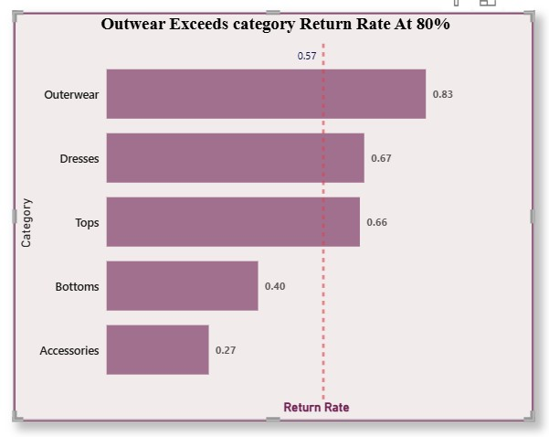

High Risk: Outerwear is the highest-risk category with a return rate of 83%.
Comparison: Accessories (27%) and Bottoms (40%) have significantly lower return rates.

Chart 3: Size Issues Accounts for 45% of Total Returns

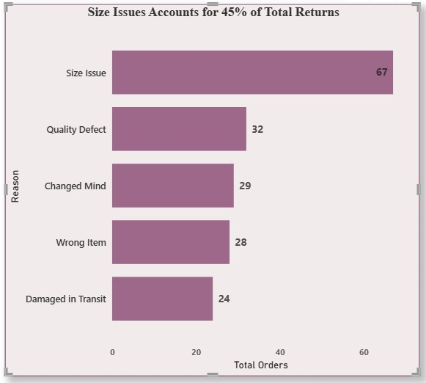

Primary Reason: Size Issues are the top reason for returns, affecting 67 total orders.
Secondary Reasons: Quality Defects (32 orders) and "Changed Mind" (29 orders) follow in frequency.

Chart 4: Channel Risk Analysis
Instagram Risk: The Instagram Shop shows a very high return rate of 74% for both new and returning customers.

Website Stability: The Website is the most reliable channel with a lower return rate of 44%.

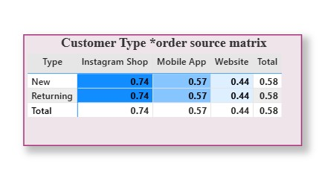

Chart 5: COD Orders Drive 94% of Total RTO Cases

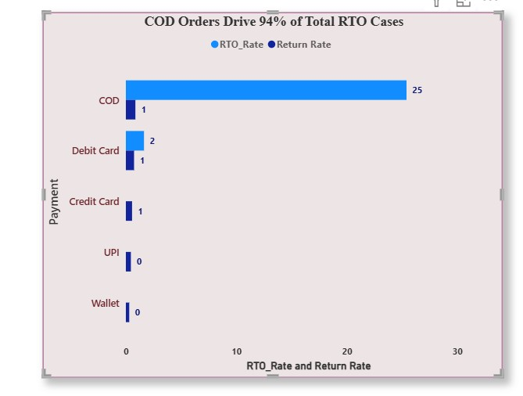

- Delivery Refusal: Cash on Delivery (COD) has a high RTO rate of 25.4%, whereas UPI and Credit Cards are under 1%.
Strategic Recommendations
- Size Guide: Implement an AI Size Recommender to reduce the 45% return rate caused by fit issues.
- Incentivize Prepaid: Offer a 5% discount for prepaid orders to reduce high-risk COD transactions.
- Quality Audit: Review Outerwear design and Instagram marketing photos to ensure they match the physical product.

Section 5: Problem-Solving & Business Recommendations
Part A: Root Cause Hypothesis
Based on the analysis, the three main reasons for the return rate increasing from 12% to 19% are:
- Size Inconsistency: This is the biggest issue, causing 45% of all returns (67 orders).
- Instagram Shop Risk: Orders from Instagram have a very high 74% return rate, showing a gap between social media photos and the real product.
- COD Issues (RTO): Cash on Delivery orders have a 25.4% RTO rate, which is much higher than prepaid orders (less than 1%). Part B: Recommended Actions AI Size Recommender:
- Change: Add a tool to help customers find their correct size.
- Target: High-return categories like Outerwear (83%) and Dresses (67%).
Expected Impact: Can reduce size-related returns by 20-30%.
Prepaid Incentives:
- Change: Offer a 5% discount for paying online instead of COD.
- Impact: Will reduce the 25.4% RTO rate caused by COD refusals.
Instagram Content Audit:
Change: Ensure Instagram photos match the actual product quality.
Impact: Will help lower the 74% return rate from this channel.

Part C: A/B Testing
- I would run an A/B test on Outerwear pages. Half of the users will see a "Fit Video" and the other half a standard chart. Since Outerwear has an 83% return rate, this test is very important. Part D: Assumptions & Limitations
Assumptions: I assumed that the 14-day delay in returns is directly linked to the sales peak.
Limitations: The data doesn't include customer comments, which would better explain "Quality Defects" (32 orders). Open-Ended Questions (Simple Answers) On stopping returns for items under ₹999:
- Instead of stopping returns, we should give Store Credit instead of cash refunds. This saves money while keeping the customer happy.
On the 40% Sale:
- We must use Prepaid-only for the sale to avoid COD RTO risks. Also, hire more staff 14 days after the sale starts to handle returns.
On Free Alterations:
- If the cost of a local tailor is less than the shipping/restocking cost (around ₹300-500), it will be very cost-effective for the 45% of size-related returns.

